INSTITUTIONAL PROGRAM REVIEW 2011-12
Program Efficacy

Purpose of Institutional Program Review

Welcome to the Program Efficacy phase of the San Bernardino Valley College Program Review process. Program Review is a systematic process for evaluating programs and services annually. The major goal of the Program Review Committee is to evaluate the effectiveness of programs, (comma not needed here) and to make informed decisions about budget and other campus priorities.

The Institutional Program Review Committee is authorized by the Academic Senate to develop and monitor the college Program Review process, receive unit plans, utilize assessments as needed to evaluate programs, recommend program status to the college president, identify the need for faculty and instructional equipment, and interface with other college committees to ensure institutional priorities are met.

The purpose of Program Review is to:
q Provide a full examination of how effectively programs and services are meeting departmental, divisional, and institutional goals
q Aid in short-range planning and decision-making
q Improve performance, services, and programs
q Contribute to long-range planning
q Contribute information and recommendations to other college processes, as appropriate
q Serve as the campus’ conduit for decision-making by forwarding information to or requesting information from appropriate committees

Our Program Review process is two-fold. It includes an annual campus-wide needs assessment in the fall, (comma not needed here)and an in-depth review of each program every three years that we call the Program Efficacy phase. Instructional programs are evaluated the year after content review, and every three years thereafter, and other programs are placed on a three-year cycle by the appropriate Vice President.

An team of three disinterested committee members will meet with you to carefully review and discuss your document. You will receive detailed feedback regarding the degree to which your program is perceived to meet institutional goals. The rubric that the team will use to evaluate your program is included with this e-mail

When you are writing your program evaluation, you may contact efficacy team assigned to review your department or your division representatives for feedback and input. The list of readers is being sent to you with these forms as a separate attachment.

Completed documents should be sent to, Program Review Co-Chairs and your Division Dean by November 2, 2011. It is the writer’s responsibility to be sure the Committee receives the forms on time.

In response to campus wide feedback that program review be a more interactive process, the committee piloted a new program efficacy process in Spring 2010 that included a review team who will interview and/or tour a program area during the efficacy process. Another campus concern focused on the duplication of information required for campus reports. The efficacy process now incorporates the Educational Master Plan One-Page Summary (EMP Summary) and strives to reduce duplication of information while maintaining a high quality efficacy process.

Program Efficacy, 2011/2012

Complete this cover sheet as the first page of your report.

Program Being Evaluated
Geography/GIS

Name of Division
Science and Health

Name of Person Preparing this Report Extension
Todd Heibel 8638

Name of Department Members Consulted
Vanessa Engstrom (Full-Time GEOG and GIS); Ramaa Mukundan, Edmund Ogbuchiekwe, Steven Sandlin, and Lisa Schmidt (Adjunct GEOG); and Robert Conrad, Jeffrey Krizek, and Solomon Nimako (Adjunct GIS)

Name of Reviewers
Paula Ferri-Milligan, Edward Jones, Kevin Kammer

Work Flow | Due Date | Date Submitted
Date of initial meeting with department |  | 10/19/11
Rough Draft submitted to Program Review Team | 10/19/11
Report submitted to Program Review Team | 11/02/11

Staffing
List the number of full and part-time employees in your area.
Classification | Number Full-Time | Number Part-time, Contract | Number adjunct, short-term, hourly
Managers | 1 (Sci Div Dean) | 0 | 0
Faculty | 2 | 0 | 7
Classified Staff | 0 | 0 | 0
Total | 3 | 0 | 7

GEOGRAPHY
 | FTES | Chart 1 | 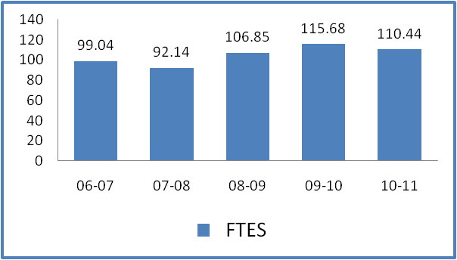
06-07 | 99.04
07-08 | 92.14
08-09 | 106.85
09-10 | 115.68
10-11 | 110.44
 |  | Chart 2
 |  | 04-05 | 05-06 | 06-07 | 07-08 | 08-09 | 09-10 | 10-11
Duplicated Enrollment |  | 1,102 | 1,013 | 963 | 952 | 1,118 | 1,183 | 1,124
FTEF |  | 6.68 | 6.06 | 5.80 | 5.00 | 6.54 | 6.14 | 5.94
WSCH per FTEF |  | 515 | 475 | 512 | 494 | 490 | 565 | 558
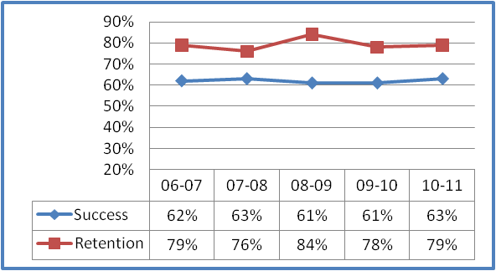
Chart 3

 | Success | Retention
06-07 | 62% | 79%
07-08 | 63% | 76%
08-09 | 61% | 84%
09-10 | 61% | 78%
10-11 | 63% | 79%
 |  |  | Chart 4
 |  | 04-05 | 05-06 | 06-07 | 07-08 | 08-09 | 09-10 | 10-11
Sections |  | 37 | 33 | 37 | 39 | 43 | 38 | 33
% of online enrollment
Degrees awarded |  | 0 | 0 | 1 | 0 | 0 | 0
Certificates awarded
Data includes: SBVC, SOFF and SBBHS

G.I.S.
 | FTES | 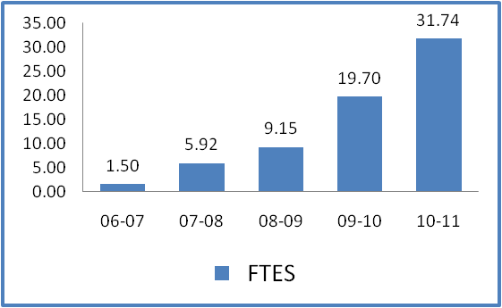 | Chart 1
06-07 | 1.50
07-08 | 5.92
08-09 | 9.15
09-10 | 19.70
10-11 | 31.74
 |  |  | Chart 2
 |  | 04-05 | 05-06 | 06-07 | 07-08 | 08-09 | 09-10 | 10-11
Duplicated Enrollment |  |  |  | 15 | 72 | 89 | 186 | 239
FTEF |  |  |  | 0.20 | 1.32 | 1.69 | 1.69 | 2.45
WSCH per FTEF |  |  |  | 225 | 135 | 162 | 350 | 389
 |  |  |  | Chart 3
 | Success | Retention
06-07 | 60% | 67%
07-08 | 72% | 79%
08-09 | 76% | 85%
09-10 | 78% | 91%
10-11 | 77% | 88%
 |  | Chart 4
 |  | 04-05 | 05-06 | 06-07 | 07-08 | 08-09 | 09-10 | 10-11
Sections |  | 0 | 0 | 1 | 6 | 8 | 10 | 14
% of online enrollment |  | 0% | 0% | 0% | 0% | 0% | 0% | 29%
Degrees awarded
Certificates awarded |  | 1 | 0 | 0 | 0 | 10* | 10*
Data includes: SBVC, SOFF and SBBHS
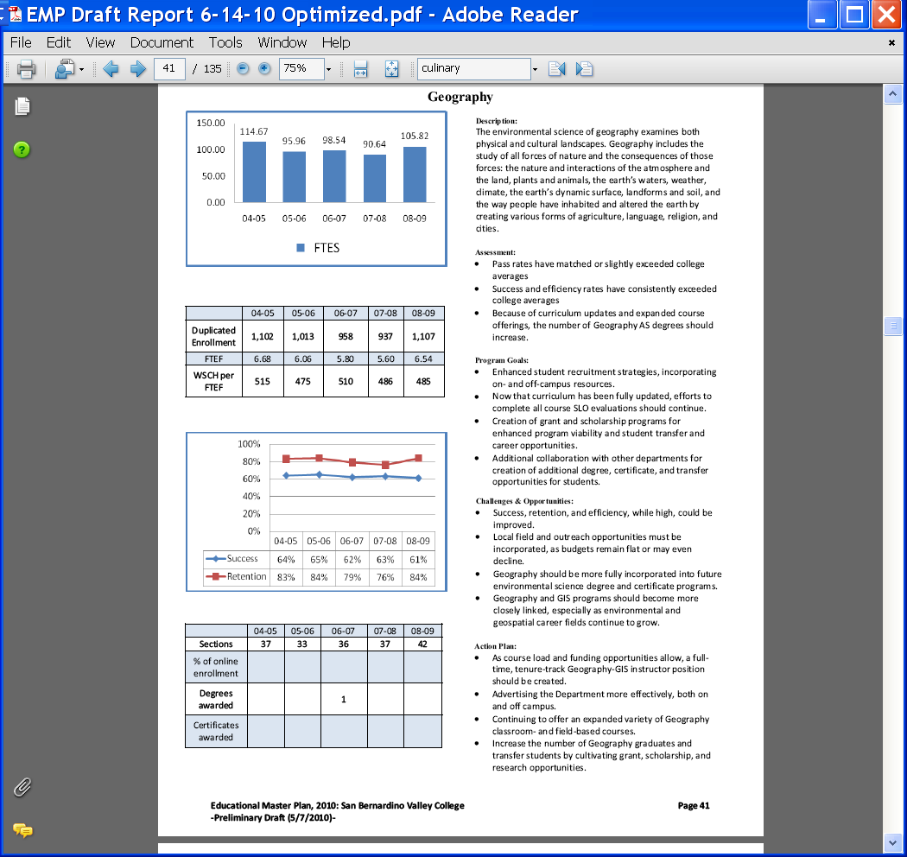

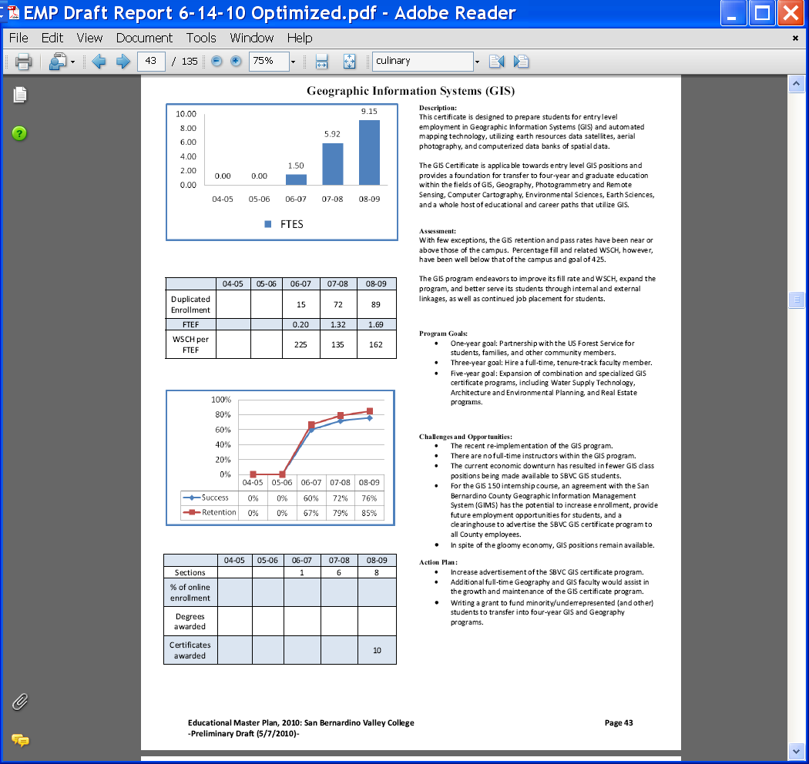

Part I. Questions Related to Strategic Initiative: Access

Use the demographic data provided to describe how well you are providing access to your program by answering the questions below.
Demographic Information
Strategic Initiative | Institutional Expectations
 | Does Not Meet | Meets
Part I: Access
Demographics | The program does not provide an appropriate analysis regarding identified differences in the program’s population compared to that of the general population | The program provides an analysis of the demographic data and provides an interpretation in response to any identified variance.  If warranted, discuss the plans or activities that are in place to recruit and retain underserved populations.
Pattern of Service | The program’s pattern of service is not related to the needs of students. | The program provides evidence that the pattern of service or instruction meets student needs.  If warranted, plans or activities are in place to meet a broader range of needs.

Geography |  | Campus
21.73% | African-American | 18.55
2.31% | Asian | 4.42
0.58% | Native American | 0.74
0.19% | Pacific Islander | 1.35
0.77% | Filipino | 1.91
54.23% | Hispanic | 48.62
15.19% | White | 20.32
2.69% | Multi-Ethnicity | 1.35
2.31% | Unknown | 3.48
49.23% | % - Male | 41.4
50.58% | % - Female | 58.4

G.I.S. |  | Campus
12.75% | African-American | 18.55
11.76% | Asian | 4.42
0.00% | Native American | 0.74
1.96% | Pacific Islander | 1.35
1.96% | Filipino | 1.91
30.39% | Hispanic | 48.62
37.26% | White | 20.32
1.96% | Multi-Ethnicity | 1.35
1.96% | Unknown | 3.48
67.65% | % - Male | 41.4
32.35% | % - Female | 58.4

Does the program population reflect the college’s population? Is this an issue of concern? If not, why not? If so, what steps are you taking to address the issue?

Geography:

Within Geography, the following demographic groups are overrepresented:
- African-American,
- Hispanic,
- Multi-Ethnicity, and
- Male.

The preceding cohorts are likely overrepresented for the following reasons (reasons for variance):
- Physical geography lecture (GEOG 110) and laboratory (GEOG 111) comprise the greatest number of Geography sections offered during the fall, spring, and summer semesters. This reflects a longtime and continued demand for transfer-level, physical science (natural science) courses. Because GEOG 110 and 111 comprise the requisite four-unit, physical science transfer credit into CSU, UC, and other common transfer destinations, it remains a popular choice for transfer-minded SBVC students. For better or worse, many students perceive these courses as more approachable and less daunting than other physical science courses (e.g. astronomy, biology, chemistry, geology, and physics). Students may also satisfy physical science transfer requirements by taking GEOG 114: Weather and Climate, although this course is offered only during the spring semester.
- In addition to satisfying physical science transfer requirements, selected geography courses can also satisfy social science transfer requirements. These courses include: GEOG 102: Cultural Geography, GEOG 106: Geographic Perspectives on the Environment, and GEOG 120: World Regional Geography. However, students have a greater number of social science transfer choices across the SBVC curriculum.
- Historically, students who comprise the preceding cohorts (overrepresented) enter college with a lack of basic skills. Of course, this is a gross generalization. Nonetheless, when students lack basic skills (regardless of ethnicity or gender) they tend to select courses according to perceived ease and opportunities for success. Rightly or wrongly, many geography courses are perceived to be more accessible to students than many of their Science Division counterparts. This may be partially a result of a lack of basic skills prerequisites – including reading, English, and mathematics – for SBVC geography courses. In spite of basic skills advisories, some students enroll in geography courses with the impression that they will be “easy.” Unfortunately, students who lack basic skills are not successful within physically- and socially-oriented geography courses. Therefore, all SBVC geography course curriculum will be revised during the coming semesters such that basic skills are included as prerequisities.
- The SBVC Geography Department would also like to capture students who successfully complete one or more geography courses as geography majors. In other words, the Geography Department endeavors to increase the number of Geography AS degrees awarded, as well as number of students who transfer into four-year geography degree programs. As evidenced by the low number of Geography AS degrees awarded at SBVC, while large numbers of students enroll in geography courses, few become geography majors. Recruitment of additional geography majors, especially from our over- and underrepresented cohorts, would greatly benefit our students with additional transfer and career options.

Overrepresentation of several of the above groups, relative to the college student population, is a benefit to the Geography program in particular and field in general. According to a 2006 Association of American Geographers (AAG) Diversity Task Force publication¹, diversity among geography faculty and undergraduate students at surveyed community colleges, liberal arts colleges, and major research universities is low. For example, the survey found that among 74 public and private institutions who participated in the survey, 88 percent of geography faculty identified as white, non-Hispanic, 7.1 percent as Asian, 3.6 percent as black, non-Hispanic, 1.1 percent as Hispanic, and 0.2 percent as Native American. Male geography faculty outnumbered female faculty, 73.4 percent compared to 26.6 percent.

White, non-Hispanic males similarly dominate the demographic situation for undergraduate students in geography. Among 66 public and private institutions who participated in the survey, 85.6 percent of undergraduate geography students identified as white, non-Hispanic, 6 percent Hispanic, 4.6 percent Asian, 3.2 percent black, non-Hispanic, and 0.6 percent Native American. Males outnumber females by a ratio of approximately 1.8 to 1.

Within geography, the following demographic groups are underrepresented:
- Asian,
- Native American,
- Pacific Islander,
- Filipino,
- White, and
- Female.

The preceding cohorts are likely underrepresented for the following reasons (reasons for variance):
- These cohorts may enter college better prepared than other groups. If this is the case, then they may choose physical and social science courses that are perceived as more rigorous. In other words, if these cohorts are better prepared in terms of basic skills development, then they may assess at a higher level within English and mathematics. They may also feel that their career prospects are better within other fields (e.g. astronomy, biology, chemistry, geology, physics, as well as social science and humanities fields).
- The Geography Department may need to better target recruitment and advertising efforts toward these cohorts. At the same time, the department must balance continued service to overrepresented cohorts.

Combined with the overrepresented groups, our underrepresented groups within the SBVC Geography program provide interesting sets of challenges and opportunities. For the most part, our local campus and community demographics strongly influence our student population. Although the male to female ratio is nearly one to one and not reflective of campus demographics, it is much closer to parity than the geography departments reported within the aforementioned survey. In addition, there has been a recent push to enroll greater numbers of men in college, as the economic downturn has disproportionately impacted them.

While diversity programs such as the AAG Enhancing Diversity Award and AAG Community College Travel Grant encourage greater minority student (and faculty) participation within the field of geography, our program endeavors to recruit greater numbers of geography majors (AS degree), especially from traditionally and historically underrepresented groups such as women, Hispanics, African Americans, Asians, and Native Americans. This can be achieved through existing elementary, middle school, and high outreach programs, Geography Awareness Week activities, GIS Day activities, guest speakers, and normal classroom activities.

GIS:

Within GIS, the following demographic groups are overrepresented:
- Asian,
- Pacific Islander,
- Filipino,
- White,
- Multi-Ethnicity, and
- Male.

Within GIS, the following demographic groups are underrepresented:
- African-American,
- Native American,
- Hispanic, and
- Female.

While the GIS field appears to be similarly overrepresented in terms of white, non-Hispanic males², there are sizable percentages of Asian, Hispanic, African-American, and female students within the SBVC GIS program. However, much work remains to be done in order to recruit additional Hispanic, African, American, Native American, and female GIS students. As with the Geography program, this can be achieved through existing elementary, middle school, and high outreach programs, Geography Awareness Week activities, GIS Day activities, guest speakers, and normal classroom activities.

¹Final Report: An Action Strategy for Geography Departments as Agents of Change: A Report of the AAG Diversity Task Force: October 2006.
²Richardson, Doug, Geography Education and GIS Professional Development, ArcNews Online, Winter 2008/2009.

Plans and activities to recruit and retain over- and underrepresented cohorts within Geography and GIS:
- Develop grant and other non-credit-type programs – especially within the science, technology, engineering, and mathematics (STEM) areas – in order to attract underrepresented populations (both GEOG and GIS, for example grants targeted to Hispanic Serving Institutions (HSIs)).
- Utilize the Geography Club (and perhaps create a GIS Club) to attract students in an extracurricular framework.
- Participate more fully within “Women in Science” and “Science Day” events.
- Better incorporate over- and underrepresented populations within “Geography Awareness Week” and “GIS Day” events.
- Invite speakers from off campus who will better appeal to over- and underrepresented groups. Specifically, these speakers can present on topics of geography undergraduate and graduate degree programs, as well as careers within the geographical sciences.
- Cultivate partnerships with the District Applied Technology and Training Center (ATTC) and Professional Development Center (PDC) to develop workforce preparedness and college preparedness programs. This will be especially helpful for students interested in the GIS program and careers.
- Expand focus and recruitment for geography and GIS majors and related careers within elementary, middle school, and high school outreach events.
- Emphasize the broad applicability of geography and GIS to myriad social and natural science majors and careers – including law, marketing, environment, real estate, computing, transportation, and planning – within the following venues: part of the classroom curriculum, on-campus outreach events, off-campus outreach events, credit and non-credit courses and summer grant programs, workshops, and other means.
- Utilize current (and future) information technologies and platforms, including: school and department websites, Blackboard, iTunes U, Edustream, podcasts, YouTube, and other means.
- Invite students to participate in local and regional professional geography conferences (e.g. California Geographical Society (CGS), Association of Pacific Coast Geographers (APCG), Associated of American Geographers (AAG), Inland Empire GIS User Group, and ESRI International User Conference).
- Coordinate with textbook publishers to better retain and recruit underrepresented cohorts.

Pattern of Service
How does the pattern of service and/or instruction provided by your department serve the needs of the community? Include, as appropriate, hours of operation/pattern of scheduling, alternate delivery methods, weekend instruction/service.

Both Geography and GIS programs offer a variety of schedules to meet the needs of traditional and working students:

Geography:
- Mon and Wed:
  - 8:00 to 9:20 AM,
  - 9:30 to 10:50 AM,
  - 11:00 AM to 12:20 PM,
  - 1:00 to 3:50 PM (lab sections),
  - 4:00 to 5:50 PM (late-start sections), and
  - 6:00 to 8:50 PM (evening lec/lab sections).

- Tue and Thu:
  - 8:00 to 9:20 AM,
  - 9:30 to 10:50 AM,
  - 11:00 AM to 12:20 PM,
  - 1:00 to 3:50 PM (lab sections),
  - 4:00 to 5:50 PM (late-start sections), and
  - 6:00 to 8:50 PM (evening lec/lab sections).

- Fri:
  - 9:00 to 11:50 AM (lec/lab sections),
  - 6:00 to 7:50 PM (late-start Fri/Sat lec section), and
  - 8:00 to 9:50 PM (late-start Fri/Sat lab section).

- Sat:
  - 8:00 AM to 12:20 PM (late-start Fri/Sat lec section), and
  - 1:00 to 5:20 PM (late-start Fri/Sat lab section).

GIS:
- Mon and Wed:
  - 5:30 to 9:50 PM (eight- and nine-week sections).

- Tue and Tue-Thu:
  - 6:00 to 9:50 PM (18-week sections).
  - 11:00 AM to 1:20 PM (14-week sections).

- Fri and Sat:
  - 5:00 to 8:50 PM.
  - 8:00 AM to 1:50 PM (eight- and nine-week sections).

Both Geography and GIS programs have the following courses approved for distributed education (DE) delivery: GEOG 102: Cultural Geography, GEOG 110: Physical Geography (lecture), GEOG 120: World Regional Geography, and GIS 130: Introduction to GIS. At this time, only GEOG 110 and GIS 130 have been offered via interactive television (ITV) format to our students at the Big Bear campus. It is anticipated, however, that our programs will offer a larger suite of courses – those approved for DE delivery – via ITV, hybrid, and fully online methods. Further, selected full-time and adjunct faculty are undergoing training for ITV and online delivery methods, including Blackboard course management system and Edustream. At this time, geography and GIS students are being surveyed to locate any gaps within our pattern of service.

Part II: Questions Related to Strategic Initiative: Student Success
Strategic Initiative | Institutional Expectations
 | Does Not Meet | Meets
Part II: Student Success - Rubric
Data demonstrating achievement of instructional or service success | Program does not provide an adequate analysis of the data provided with respect to relevant program data. | Program provides an analysis of the data which indicates progress on departmental goals.  If applicable, supplemental data is analyzed.
Student Learning Outcomes and/or Student Achievement Outcomes | Program has not demonstrated that they have made progress on Student Learning Outcomes (SLOs) and/or Service Area Outcomes (SAOs) based on the plans of the college since their last program efficacy. | Program has demonstrated that they have made progress on Student Learning Outcomes (SLOs) and/or Service Area Outcomes (SAOs) based on the plans of the college since their last program efficacy.

Provide an analysis of the data and narrative from the program’s EMP Summary and discuss what it reveals about your program. (Use data from the Charts 3 & 4 that address Success & Retention and Degrees and Certificates Awarded on page 3 of this form.)
Geography Success, Retention, and Degree Data:

Year: G Success:¹ C Success:² G Retention:¹ C Retention:² Degrees:
06-07 62% 61.63% 79% 78.49% 1
07-08 63% 61.82% 76% 79.29% 0
08-09 61% 63.02% 84% 79.12% 0
09-10 61% 61.20% 78% 78.90% 0
10-11 63% 63.92% 79% 81.38% 0

GIS Success, Retention, and Certificate Data:

Year: G Success:³ C Success:² G Retention:³ C Retention:² Certificates:
06-07 60% 61.63% 67% 78.49% 0
07-08 72% 61.82% 79% 79.29% 0
08-09 76% 63.02% 85% 79.12% 10
09-10 78% 61.20% 91% 78.90% 10
10-11 77% 63.92% 88% 81.38% 8

¹Success and retention rates for the Geography program.
²Success and retention rates for the SBVC campus, based on the spring semester.
³Success and retention rates for the GIS program.

In general, success and retention for both Geography and GIS programs reflects those of the Science Division and SBVC campus. Nonetheless, these data have the potential to improve such that our students will become more successful. In particular, the programs have identified the following trends and areas of concern and align with departmental goals:

Departmental Goal: Implement English and mathematics prerequisites for Geography and GIS courses:
- In an ongoing effort to improve student success within Geography and GIS programs, curriculum is being revised to include basic skills prerequisites. Specifically, these programs shall include English prerequisites that assume reading, writing, and communication proficiency. In addition, mathematics proficiency is a key component.

Departmental Goal: Increase student success and retention:
- While success and retention have remained somewhat stable within Geography, they have generally increased within GIS. However, some variance (fluctuation) has occurred. This is generally in line with overall campus trends. Nonetheless, both programs endeavor to increase success and retention via establishment of prerequisites, development of grants to support tutoring and student success workshops, and improved advertisement through existing on- and off-campus activities.

Departmental Goal: Hire a full-time GIS faculty member:
- An additional component that has the potential to increase student success and retention is to continue lobbying Program Review and related official processes in an effort to hire a full-time GIS faculty member. Alternatively, a full-time faculty member split between Geography and GIS programs would be beneficial. At present, with the exception of one section, there is no full-time faculty support for the GIS program. Although our adjunct GIS faculty represent industry experts, they cannot guarantee long term stability and support for the GIS program. Equally, it is difficult (and unfair) to ask adjunct faculty to develop long term strategies to ensure student success and retention, including advertising and recruitment. A full-time faculty member would be able to devote considerable time, thought, and action toward these endeavors.

Departmental Goal: Continue grant exploration and development to supplement declining budgets:
- Using the summer 2010 San Bernardino County Workforce Investment Board (WIB) and American Recovery and Relief Act (ARRA) nine-week GIS/basic and career skills grant program as a model, additional GIS and geography programs could be developed – perhaps using WIB, ARRA, NSF (National Science Foundation), and Perkins (related to career and technical education (CTE)) funding – that combine cartographic, spatial, and computing skills with basic reading, mathematics, communication, English, and career skills.

Departmental Goal: Collaborate with other departments in order to develop interdisciplinary courses:
- Learning communities (e.g. based on models including Tumaini, Puente, and Valley Bound), supplemental learning (e.g. tutoring and workshops), and interdisciplinary – including team-taught – courses could also be included in an multifaceted effort to improve student success and retention.

Departmental Goal: Collaborate with other community college and four-year geography and GIS departments:
  - Meet with faculty chairs and faculty members within geography and GIS departments at area community colleges and four-year institutions in order to ensure appropriate curriculum development, improve transfer rates, and improve employability.

Supplemental Data
Provide any additional information, such as job market indicators, standards in the field or licensure rates that would help the committee to better understand how your program contributes to the success of your students.
Job Market Indicators:

Available career paths for those with AS, BS, and BA Degrees within Geography and GIS may include (source: Association of American Geographers: www.aag.org):

• Educator (secondary education and higher education),
• City/Urban Planner,
• Data Technician,
• Environmental Analyst/Director/Planner/Specialist/ Technician,
• Geospatial Analyst/Coordinator/Manager/Programmer/ Technician,
• GIS Analyst/Coordinator/Manager/Programmer/ Technician,
• Marketing Manager,
• Physical Scientist,
• Policy Analyst,
• Regional Director,
• Transportation Planner,
• Epidemiologist/Medical Geographer, and
• Demographer/Census Data Analyst.

Our Geography and GIS programs prepare students for these careers primarily by preparing them for transfer into four-year degree programs. However, our GIS certificate program also prepares students for entry-level GIS technician positions. While students are encouraged to complete a four-year (or even graduate-level) GIS degree, they learn skill sets that prepare them for employment as technicians within private consulting firms (e.g. environmental consulting firms) and public sector (e.g. San Bernardino County, US Forest Service, and San Bernardino City Unified School District). In addition, students are encouraged to enroll in the GIS 098: GIS Work Experience course. Within this course, students work in an internship environment that better prepares them for future careers within the broad fields of geography and GIS.

Standards in the Field:

Students majoring and pursuing careers within the fields of Geography and GIS should remain aware of:
• Geographic terminology (within Human and Physical Geography),
• Geography software and technology (GIS and GPS),
• Social, political, and economic changes, as they impact the environment, and
• Geopolitics

Licensure Rates:

Geographers and GIS technicians and analysts are not required to possess licenses, per se, within the State of California. However, related fields, including: real estate, surveying and civil engineering, landscape architecture, and law practice require licensure and registration.

Advisory Committee Recommendations:

Because Geography and GIS are inherently related, a preliminary Advisory Committee has been created. Present members include: ESRI in Redlands, CSU-San Bernardino Geography (and GIS and Environmental Studies) Department, US Forest Service (field office in San Bernardino), County of San Bernardino Geographic Information Management Services (GIMS), Colton-Redlands-Yucaipa ROP (Regional Occupational Program), San Bernardino City Municipal Water District, SBVC Water Supply Technology (WST) Department, SBVC Architecture and Environmental Design Department, SBVC Office of Research, Planning, Development, and Grants, and Air Quality Management District (AQMD). The next advisory committee meeting is scheduled on Wednesday, 7th December 2011. Future plans include collaborative WST-GIS (and Geography) advisory committee meetings twice each academic year, once in December and once in May.

Student Learning Outcomes and/or Student Area Outcomes
Demonstrate that your program has continued to make progress on Student Learning Outcomes (SLOs) and/or Service Area Outcome (SAOs) based on the plans of the college since the program’s last efficacy report.
See Strategic Initiative 5.1

Since the previous efficacy report, the following Geography courses have completed SLO assessments: GEOG 102, GEOG 110, and GEOG 120. The program intends to complete SLO assessments for GEOG 106 and 111 during the fall 2011 semester and GEOG 114 during the spring 2012 semester. All Geography courses currently listed within the SBVC catalogue will have been assessed by the end of the spring 2012 semester. Program-level assessments for the Geography AS degree have not yet been completed. The department intends to fulfill this obligation by the end of the spring 2012 semester.

To date, no GIS courses have completed SLO assessments. A lack of a full-time GIS faculty member has hindered progress on this endeavor. Fortunately, and with the assistance of a full-time faculty colleague, SLO assessments for the following GIS courses will be completed by the end of the fall 2011 semester: GIS 130, GIS 131, GIS 133, and GIS 135. By the end of the spring 2012 semester, the program intends to complete assessments for GIS 039, 098, and 137 courses. Provided that the program adheres to this schedule, all GIS courses will have been assessed by the end of the spring 2012 semester. Program-level assessments for the GIS certificate have not yet been completed. The program intends to fulfill this obligation by the end of the spring 2012 semester.

In addition to a dearth of full-time faculty to assist with SLO revision, assessment, and recording, there remain confusion and lack of agreement among the CTA union, SBVC administration, and District Chancellor’s office on the issue of SLO workload and compensation. Elumen SLO data capture has not been fully implemented and few SBVC faculty, including those within the Geography and GIS departments, have been trained in its use and application. Therefore, progress has remained uneven.

Although incomplete and admittedly falling short of college goals (and attendant accreditation goals), the programs endeavor to complete SLO assessment, continue revision of SLOs, and record SLO assessment data for each student at the course- and program level. One method to achieve this when full-time faculty are in short supply is to utilize existing examination, quiz, and project questions as SLO assessments.

SLO Course and Program Completion Table:
Course: | SLO Completed? | Plan to Complete by:
GEOG 102: Cultural Geography | Yes
GEOG 106: Geographic Perspectives on the Environment | No | Fall 2011
GEOG 110: Physical Geography Lecture | Yes
GEOG 111: Physical Geography Lab | No | Fall 2011
GEOG 114: Weather and Climate | No | Spring 2012
GEOG 120: World Regional Geography | Yes
GEOG AS Degree Program | No | Spring 2012
GIS 039: GPS Field Techniques | No | Spring 2012
GIS 098: GIS Work Experience | No | Spring 2012
GIS 130: Intro to GIS | No | Fall 2011
GIS 131: GIS Applications | No | Fall 2011
GIS 133: GIS Cartography and Base Map Development | No | Fall 2011
GIS 135: Spatial Analysis with GIS | No | Fall 2011
GIS 136: GIS for Science, Government, and Business | No | When next offered
GIS 137: GIS Advanced Applications | No | Spring 2012
GIS Certificate Program | No | Spring 2012

Part III. Questions Related to Strategic Initiative: Institutional Effectiveness
Strategic Initiative | Institutional Expectations
 | Does Not Meet | Meets
Part III: Institutional Effectiveness - Rubric
Mission and Purpose | The program does not have a mission, or it does not clearly link with the institutional mission. | The program has a mission, and it links clearly with the institutional mission.
Productivity | The data does not show an acceptable level of productivity for the program, or the issue of productivity is not adequately addressed. | The data shows the program is productive at an acceptable level.
Relevance, Currency, Articulation | The program does not provide evidence that it is relevant, current, and that courses articulate with CSU/UC, if appropriate. | The program provides evidence that the curriculum review process is up to date. Courses are relevant and current to the mission of the program.  Appropriate courses have been articulated or (?) transfer with UC/CSU or plans are in place to articulate appropriate courses.

Mission and Purpose:
SBVC Mission: San Bernardino Valley College provides quality education and services that support a diverse community of learners.
What is the mission statement of the program?
Geography:

The Geography Department provides quality education to students interested in fulfilling general education (GE) requirements in physical and social sciences, as well as mathematics, engineering, environmental studies/sciences, pre-medicine, and/or pre-law.

Specifically, the Department prepares students for careers in the fields of geography, geographic information systems (GIS), education, cartography, demography, surveying, transportation and logistics, real estate, marketing, law, epidemiology, environmental studies, and other positions that demand knowledge and interpretation of spatial patterns. In addition, Geography courses allow students to more fully comprehend real-world, everyday cultural and environmental phenomena and news events. Students are therefore better equipped to make informed life decisions.

GIS:

This certificate is designed to prepare students for entry level employment in Geographic Information Systems (GIS) and automated mapping technology, utilizing earth resources data satellites, aerial photography, and computerized data banks of spatial data. Students working for certificates must have a basic knowledge of arithmetic, reading, and writing in order to learn and work in the occupations they select.

Not only is the GIS Certificate applicable toward entry level GIS positions but also provides a foundation for transfer to four-year and graduate education within the fields of GIS, Geography, Photogrammetry and Remote Sensing, Computer Cartography, Environmental Sciences, Earth Sciences, and a whole host of educational and career paths that utilize GIS.

Specifically, the GIS Program prepares students for careers in the fields of geography, geographic information systems (GIS), education, cartography, demography, surveying, transportation and logistics, real estate, marketing, law, epidemiology, environmental studies, and other positions that demand knowledge and interpretation of spatial patterns. In addition, GIS courses allow students to more fully comprehend real-world, everyday cultural and environmental phenomena and news events. Students are therefore better equipped to make informed life decisions.

How does this purpose relate to the college mission?
Geography:

The mission of the College is to provide quality education to a diverse community of learners and is consistent with the purpose and mission of the Geography Department. The Department serves a diverse community of learners, as evidenced in its demographic data (please refer to the Demographic Information table in Part I). In addition, the Department adheres to the college vision statement by creating “informed, responsible, and active members of society” and value statement where “students become self-sufficient learners and contributing members of society.”

GIS:

The mission of the College is to provide quality education to a diverse community of learners and is consistent with the purpose and mission of the GIS Program. The Program serves a diverse community of learners, as evidenced in its demographic data (please refer to the Demographic Information table in Part I). In addition, the Department adheres to the college vision statement by creating “informed, responsible, and active members of society” and value statement where “students become self-sufficient learners and contributing members of society.”

As mentioned within the “Demographic Information” section (Part I), GIS students contribute to access, student success, technology, institutional effectiveness, and partnerships by working on real-world campus projects. For example, GIS students will continue to work with the Office of Institutional Research, Planning, and Grants and Office of the Vice President of Administrative Services on projects that will benefit the entire Campus and District.

GIS also relates to broader community, regional, national, and global environmental (green) initiatives. “With the growing unease and awareness among large segments of the population that remedial action must be taken to resolve the many environmental crises we now face, GIS solutions are currently being implemented around the world that provide the technological and scientific support necessary to create programs and processes designed to return our planet to a more sustainable and balanced level of use” (http://www.esri.com/library/bestpractices/gis-is-green.pdf, accessed 16 March 2009). Within our area, the GIS and Geography programs can link to not only college mission and strategic initiatives but also the Inland Empire Green Valley Initiative (refer to http://www.greenvalleynow.org, accessed 2 November 2011, for additional information).

Productivity
Provide additional analysis and explanation of the productivity data and narrative in the EMP Summary, if needed. (Use data from charts 1 and 2 (FTEs; Enrollment; FTFE and WSCH per FTFE) on page 3 of this form). Explain any unique aspects of the program that impact productivity data for example; Federal Guidelines, Perkins, number of workstations, licenses etc…
Geography Productivity:
Year | 04-05 | 05-06 | 06-07 | 07-08 | 08-09 | 09-10 | 10-11
FTES | 114.67 | 95.96 | 99.04 | 92.14 | 106.85 | 115.68 | 110.44
Enrollment | 1,102 | 1,013 | 963 | 952 | 1,118 | 1,183 | 1,124
FTEF | 6.68 | 6.06 | 5.80 | 5.00 | 6.54 | 6.14 | 5.94
Efficiency | 515 | 475 | 512 | 494 | 490 | 565 | 558

College Productivity:
Year | 04-05 | 05-06 | 06-07 | 07-08 | 08-09 | 09-10 | 10-11
FTES | 8,987.05 | 9,344.46 | 8,957.59 | 10,090.64 | 11,249.45 | 10,250.28 | 10,314.97
Enrollment | 19,394 | 19,477 | 19,420 | 20,802 | 22,494 | 21,305 | 19,169

Departmental FTES, enrollment, FTEF, and efficiency (WSCH per FTEF) have fluctuated with overall college enrollment and budgetary trends, although lagging behind during some academic years. Perhaps most importantly, efficiency appears to be on an upward trajectory (since 08-09) and has exceeded college goals (525) during the past two academic years. In addition, GEOG 102 has been offered each semester (fall and spring) and GEOG 106, GEOG 114, and GEOG 120 offered once per academic year during the past three academic years. When these courses were first offered within this more regularized schedule, student enrollment was initially below cap. However, enrollment has stabilized within all GEOG courses, although selected sections have been cut in order to abide by more stringent budgetary standards.

GIS Productivity:
Year | 04-05 | 05-06 | 06-07 | 07-08 | 08-09 | 09-10 | 10-11
FTES |  |  | 1.50 | 5.92 | 9.15 | 19.70 | 31.74
Enrollment |  |  | 15 | 72 | 89 | 186 | 239
FTEF |  |  | 0.20 | 1.32 | 1.69 | 1.69 | 2.45
Efficiency |  |  | 225 | 135 | 162 | 350 | 389

The GIS certificate program was resurrected during the spring 2006 semester. Since this time, FTES, enrollment, FTEF, efficiency, number of courses offered, and completed certificates have increased. Although efficiency must be improved to meet college goals (e.g. 525), the trend suggests that this will occur in the future. In order to increase productivity, GIS advertisement and recruitment efforts must continue. Implementation of the new college website has facilitated student inquiry and interest within the GIS program (e.g. via the “Request Information” link). However, student enrollment within GIS courses is necessarily limited to the number of computers (and software) available. In addition, it is pedagogically unsound to increase the enrollment cap significantly within GIS courses, as students require abundant assistance and faculty interaction.

Relevance and Currency, Articulation of Curriculum
Science
Geography
 | Course | Status | Last Content Review | Next Review Date
 | GEOG102 Cultural Geography | Active | 09/14/2009 | 09/14/2015
 | GEOG106 Geographic Perspectives on the Environment | Active | 10/26/2009 | 10/26/2015
 | GEOG110 Physical Geography | Active | 10/12/2009 | 10/12/2015
 | GEOG111 Physical Geography Laboratory | Active | 10/12/2009 | 10/12/2015
 | GEOG111H Physical Geography Laboratory - Honors | Active | 10/12/2009 | 10/12/2015
 | GEOG114 Weather and Climate | Active | 09/28/2009 | 09/28/2015
 | GEOG120 World Regional Geography | Active | 03/29/2010 | 03/29/2016
 | GEOG222 Independent Study in Geography | Active | 04/15/2000 | 04/15/2006
Science
Geographic Information Systems
 | Course | Status | Last Content Review | Next Review Date
 | GIS039 Global Positioning Systems (GPS) Field Techniques | Active | 10/26/2009 | 10/26/2015
 | GIS098 GIS Work Experience | Active | 10/13/2008 | 10/13/2014
 | GIS098 GIS Work Experience | Active | 10/12/2009 | 10/12/2015
 | GIS130 Introduction to Geographic Information Systems (GIS) | Active | 10/26/2009 | 10/26/2015
 | GIS131 GIS Applications | Active | 10/12/2009 | 10/12/2015
 | GIS133 GIS Cartography and Base Map Development | Active | 10/12/2009 | 10/12/2015
 | GIS135 Spatial Analysis with GIS | Active | 10/12/2009 | 10/12/2015
 | GIS136 GIS for Science, Government, and Business | Active | 10/12/2009 | 10/12/2015
 | GIS137 GIS Advanced Applications | Active | 10/12/2009 | 10/12/2015

If applicable to your area, describe your curriculum by answering the following questions.
The Content Review Summary from Curricunet indicates the program’s current curriculum status. If curriculum is out of date, explain the circumstances surrounding the error and plans to remedy the discrepancy.
At this time, the only out of date course in the curriculum is the GEOG 222: Independent Study course. The department intends to update this course curriculum during the fall 2011 semester. All other GEOG and GIS course curriculum, including degree and certificate programs, has been updated and approved through the official curriculum process.
Articulation and Transfer
List Courses above 100 where articulation or transfer is not occurring | With CSU | With UC
GEOG 222 |  | Limited transfer to UC. Credit determined after transfer to UC.
GIS 131 |  | Not yet articulated within the UC system.
GIS 135 | Transfers as elective credit only. | Not yet articulated within the UC system.
GIS 136 |  | Not yet articulated within the UC system.
GIS 137 | Transfers as elective credit only. | Not yet articulated within the UC system.

Describe your plans to make courses qualify for articulation or transfer.
At this time, all but one Geography course – GEOG 222 – fully articulates and transfers to both CSU and UC systems. While most 100-level GIS courses fully articulate and transfer to the CSU system, GIS 135 and 137 transfer as elective credit only. At this time, comparable courses are found within the upper division. Aside from GIS 130 and 133, all other 100-level GIS courses do not yet articulate and transfer to the UC system. As with the CSU system, many GIS (and related geospatial) courses are found within the upper division.
The Geography and GIS faculty will continue to work with the SBVC articulation officer, as well as articulation officers at selected CSU and UC transfer institutions. In addition, faculty will meet with community college and four-year faculty at professional meetings, Bridge Program meetings, and regular telecommunication. Area industry and employer input will benefit these programs through twice-yearly industry advisory meetings.

Currency
Follow the link below and review the last college catalog data.
http://www.valleycollege.edu/academic-career-programs/college-catalog.aspx
Is the information given accurate? Which courses are no longer being offered? (Include Course # and Title of the Course). If not, how does the program plan to remedy the discrepancy?
Because both Geography and GIS programs have recently revised curriculum, degree, and certificate information via the content review process, all SBVC catalogue information is accurate and current. In fact, the Geography program endeavors to add the following courses: Geography of California, Field Geography, and Geospatial Mapping (most likely cross listed with GIS). These new courses are in keeping with proposed geography discipline input group (DIG) and transfer model curricula (TMC) at the state level.

Part IV. Planning
Strategic Initiative | Institutional Expectations
 | Does Not Meet | Meets
Part IV: Planning - Rubric
Trends | The program does not identify major trends, or the plans are not supported by the data and information provided. | The identifies and describes major trends in the field. Program addresses how trends will affect enrollment and planning. Provide data or research from the field for support.
Accomplishments | The program does not incorporate accomplishments and strengths into planning. | The program incorporates substantial accomplishments and strengths into planning.
Challenges | The program does not incorporate weaknesses and challenges into planning. | The program incorporates weaknesses and challenges into planning.

What are the trends, in the field or discipline, impacting your student enrollment/service utilization? How will these trends impact program planning?
Major trends may include:

- Environmental aspects related to global climate change and resource scarcity, specifically as it pertains to urbanization, air quality, and water use within the Inland Empire,
- Related mapping technologies, including GIS, GPS, and remote sensing, specifically job growth within the mapping sciences within the Inland Empire,
- Inclusion of greater numbers of previously underrepresented populations, specifically through outreach, workshop, guest speaker, and job fair events,
- Land and resource management programs, specifically through partnerships with ESRI, US Forest Service, City and County of San Bernardino, and other public and private entities within the Inland Empire, and

Depending on state and federal mandates, the demand for Geography school teachers (K-12) may increase.

The Department will continue to participate in discipline-specific and SBVC Professional Development conferences and workshops. In addition to these events, Department faculty will continue to collaborate with faculty at other California Community Colleges and four-year institutions to share ideas about pedagogy, curriculum, technology, and other current events. This dialogue will occur within professional meetings, workshops, and conferences, as well as through industry advisory committee recommendations.

The following external factors impact Geography and GIS student enrollment and service utilization:

- Student life demands,
- State of the economy, including specific job availability and marketplace demands,
- Demographic trends, including high school graduation trends,
- Federal and State funding trends,
- Transportation and related mobility issues, and
- Programs offered at competing area colleges and four-year institutions.

Accomplishments and Strengths
Referencing the narratives in the EMP Summary, provide any additional data or new information regarding the accomplishments of the program, if applicable. In what way does your planning address accomplishments and strengths in the program?

Major Geography Department accomplishments include:

- Successful hire of a full-time, tenure-track Geography Instructor (who will serve as an excellent role model, especially for women interested in Geography and other sciences),
- Implementation of the ITV (DE) Physical Geography course at the Big Bear High School site,
- Successful modification and articulation of nearly all courses and offering each GEOG course at least once during every academic year,
- Completion and approval of the Environmental Studies/Sciences AS degree program,
- Active Department in many campus outreach activities (e.g. “Super Saturday,” “Science and Math Day,” “Celebrating Women in Science and Math,” etc.),
- Faculty and student attendance at APCG (Association of Pacific Coast Geographers), CGS, and other professional geography conferences,
- Successful collaboration with publishers in the production of a customized Physical Geography textbook and laboratory manual (that saved students money), and
- Creation of a Geography scholarship fund (through the San Bernardino Valley College Foundation).
- Inclusion of Geography within a recently-awarded STEM grant such that one or more tutors will be funded.

Major GIS Certificate Program accomplishments include:

- San Bernardino County Board of Supervisors and San Bernardino Community College District Board of Trustees approval of a GIS internship program, for fulfillment of the GIS 098 course,
- Expansion of GIS 098 internship partnerships to include the US Forest Service and SBVC Office of Research and Planning,
- Dialogue with the Colton-Redlands-Yucaipa ROP for GIS course articulation and plans to include other area ROP programs for GIS articulation at campus ROP articulation workshops,
- Dialogue with the SBCCD PDC and SBVC Office of Research, Planning, Development, and Grants for course projects and internships at campus industry advisory committee meetings,
- Course and program modification, per Curriculum Content Review process,
- Completion and approval of the Environmental Studies/Sciences AS degree program,
- Active Department in many campus outreach activities (e.g. “Super Saturday,” “Science and Math Day,” “Celebrating Women in Science and Math,” etc.),
- Participation in area high school, middle school, and elementary school outreach projects,
- Coordination with area high school advanced placement (AP) GIS courses (for potential articulation agreements),
- Coordination with WST and Architecture and Environmental Planning programs (for development of combined and specialized certificate programs),
- Installation of the GIS (ESRI) software within other campus computer labs (beyond the normal classroom, HLS 231), including Library and DSPS High-Tech center,
- Faculty and student attendance at APCG, CGS, and ESRI International User Conference, and
- Funding for GIS tutors to serve in an open lab environment during the fall and spring semesters.

Challenges
Referencing the narratives in the EMP Summary, provide any additional data or new information regarding planning for the program. In what way does your planning address trends and weaknesses in the program?
Geography Program:

There are presently several barriers to student success for students taking Geography courses, including lack of math, reading, and English skills. The Department will address this within the next year through departmental prerequisites for math, reading, and English proficiency. Within the current academic year, the Department has procured one tutor (within the Student Success Center).

At present, there is too little ongoing instructional supply money for necessary classroom items, including up-to-date maps, globes, demonstration models, and laboratory supplies. While the transportation supply funding has recently been increased, it is likely that it will once again need to be supplemented, in light of increased fuel costs. Budgeting for software, specifically remote sensing software for a variety of Geography courses, will become an issue within the next one to three years.

Geography Planning:

One-year plan:
- Partnership with the US Forest Service for students, families, and other community members.
- Continued participation in “Science and Math Day,” “Women in Science,” and “Super Saturday” on-campus activities.
- Continued participation in “Route 66” and regional high school recruitment off campus.
- Regularly offering (at least once per academic year) an expanded lineup of courses, including: GEOG 102, 106, 110, 111, 114, and 120.
- Offering online, hybrid, and ITV versions of the following courses: GEOG 102, 106, 110, 114, and 120.
- Inclusion of the Geography Department within a STEM grant.

Three-year plan:
- Continue to lobby for hiring an additional full-time, tenure-track faculty member (perhaps 50% Geography and 50% GIS).
- Partnership with the American Meteorological Service (AMS) within the “Minority Scholarship” and online “Weather Studies” programs.
- Regularly offering (at least once per academic year) the GEOG 111H honors Physical Geography laboratory course.
- Expanding outreach to include regional high school and adult education students.
- Continued expansion of Distributed Education (DE) offerings for the following courses: GEOG 102, 106, 110, 114, and 120.
- Collaboration with the Science Division to submit a grant providing leadership and mentor training for our students, outreach efforts to local middle schools for “Science Saturday” workshops, and a summer bridge program for science and math success.

Five-year plan:
- Research and development of a grant to fund minority/underrepresented (and other) students to transfer into four-year Geography and Environmental Studies/Sciences programs.
- Creation of new topical courses, including Economic, Political, Urban, Hazards/Natural Disasters, and California Geography courses.
- Creation of new techniques courses, including Mapping/Survey/GPS/Geospatial and Remote Sensing of the Environment courses.
- Continued collaboration – via professional conference, workshops, and bridge program – with community college and four-year institutions in terms of the development, articulation, and career development of courses.

GIS Program:

- With one exception, there are no full-time instructors within the GIS program. Although the current GIS instructors are professional and capable (and drawn from within the GIS industry), it is difficult to guarantee the permanence of adjunct instructors. However, with the introduction of a full-time geography faculty, the stability of the GIS program should be better maintained.
- Related to the previous point, there are only two full-time faculty advocates for GIS program, the faculty chair and a full-time geography faculty member. This faculty chair must also develop and maintain growth within the Geography and Geology-Oceanography Departments, as well as contribute to the new Environmental Sciences/Studies program. These multiple roles make it difficult to focus energy and resources on the GIS program. This has proven costly for SLO development and evaluation, as well as the Curriculum Content Review cycle.
- Because many entry-level GIS positions are found within the public sector (e.g. city, county, state, and federal governments), the current economic downturn has resulted in fewer GIS positions being made available to SBVC GIS students.
- Although GIS tutors have served GIS students during past semesters, no long term funding has been procured for this important service. It will, therefore, be necessary to coordinate with the Student Success Center, Cal Works, Hi-Tech Center, and other on-campus student support services.

GIS Planning:

One-year plan:
- Partnership with the US Forest Service for students, families, and other community members.
- Continued participation in “Science and Math Day,” “Women in Science,” and “Super Saturday” on-campus activities.
- Continued participation in “Route 66” and regional high school recruitment off campus.
- Regularly offering (at least once per semester) the introductory courses, GIS 130 and 131.
- Sequencing GIS courses such that students can successfully earn a certificate within three to four semesters.
- Further integrate the GIS program into SBVC Emerging Technology and Green Technology plans.

Three-year plan:
- Continue lobbying for hiring an additional full-time, tenure-track faculty member (perhaps 50% Geography and 50% GIS).
- Offering online and hybrid (DE) versions of the following courses: GIS 130, 131, 133, 135, and 137.
- Expanding outreach to include regional high school and adult education students.
- Collaboration with the Science Division to submit a grant providing leadership and mentor training for our students, outreach efforts to local middle schools for “Science Saturday” workshops, and a summer bridge program for science and math success.
- Building upon the success of the MOU (Memorandum of Understanding) with the San Bernardino County Geographic Information Management System (GIMS) and expanding internship programs with other public and private agencies.
- Coordination with the Career and Transfer Center to assist student placement into internship (paid and unpaid) programs and four-year degree programs.

Five-year plan:
- Continued expansion of Distributed Education (DE) offerings for GIS courses, possibly including the ITV format for Big Bear and other mountain community students.
- Researching and developing a grant to fund minority/underrepresented (and other) students to transfer into four-year GIS and Geography programs and transition into related careers.
- Creation of new techniques courses, including Mapping/Survey/GPS and Remote Sensing of the Environment courses.
- Expansion of combination and specialized GIS certificate programs, including Water Supply Technology, Architecture and Environmental Planning, and Real Estate programs.
- Incorporation of Computer Science (CS) and Computer Information Technology (CIT) courses into the GIS certificate program.
- Development of a fully transferable GIS Associate Degree (AS) program.

V. Questions Related to Strategic Initiative: Technology, Campus Climate and Partnerships.
Part V: Technology, Partnerships & Campus Climate
 | Program does not demonstrate that it incorporates the strategic initiatives of Technology, Partnerships or Campus Climate.  Program does not have plans to implement the strategic initiatives of Technology, Partnerships or Campus Climate | Program demonstrates that it incorporates the strategic initiatives of Technology, Partnerships and/or Campus Climate.  Program has plans to further implement the strategic initiatives of Technology, Partnerships and/or Campus Climate.

Describe how your program has addressed the strategic initiatives of technology, campus climate and/or partnerships. What plans does your program have to further implement these initiatives?
Geography Program: Technology:

In addition to traditional lecture methods, including class discussion and whiteboard, the Geography Department is using the following technologies:

- Classroom computer and LCD projector for PowerPoint, Google Earth, World Wind, ESRI ArcView, and other computer animation software,
- VHS and DVD educational videos,
- Blackboard course management system,
- Edustream video archiving and playback system
- Student e-mail,
- Interactive television (ITV) courses linked to the Big Bear High School site, and
- Official SBVC website: http://www.valleycollege.edu/academic-career-programs/degrees-certificates/geography.aspx

In addition to continued incorporation of the above current classroom technologies, the Geography Department will consider classroom response system (CPS, otherwise known as “clicker” and free, online systems such as “Poll Everywhere”) technology. Beyond the current ITV format, the Department plans to offer hybrid and online DE formats to increase student access and FTE. For example, additional Geography courses will be developed for DE delivery, including GEOG 106 and 114. Naturally, only courses suitable to these DE formats will be implemented. Within the GEOG 114 course, the Department may partner with the American Meteorological Society (AMS) and its “online weather studies” project. The Department will continue to work closely with the College, Science Division, Audiovisual Department, Curriculum Committee, Program Review Committee, Technology Committee, and Professional Development.

GIS Program: Technology:

In addition to traditional lecture methods, including class discussion and whiteboard, the GIS Certificate Program is using the following technologies:
- Classroom computer and LCD projector for PowerPoint, Google Earth, World Wind, ESRI ArcView, ESRI ArcEDIT, ESRI ArcINFO, and other computer animation software,
- VHS and DVD educational videos,
- Blackboard course management system,
- Student e-mail, and
- ESRI Virtual Campus (on-line) courses.

In addition to continued incorporation of the above current classroom technologies, the GIS Program will offer hybrid and online DE formats to increase student access and FTE. For example, GIS 131, 133, 135, 136, and 137 will eventually be developed for DE delivery. Naturally, only courses suitable to these DE formats will be implemented. The Department will continue to work closely with the College, Science Division, Audiovisual Department, Curriculum Committee, Program Review Committee, Technology Committee, and Professional Development Committee.

An integral aspect of the GIS software – industry-standard ESRI (Environmental Systems Research Institute, a world leader in GIS software, based in Redlands, California) software – is close communication with the Foundation for California Community Colleges. For an affordable price, the District has purchased a District-wide site license for the ESRI GIS software. This allows faculty, staff, and students to use the latest versions of ArcPad, ArcIMS, ArcView, ArcInfo, ArcEditor, ArcGIS Server, and related GIS software. This is the same software that GIS analysts use on a daily basis. Because our students use and interact with this software within their GIS courses, they will be well prepared for entry-level careers and transfer to four-year institutions. For more information about the Foundation for California Community Colleges GIS software program, please view the following website: http://www.foundationccc.org/Default.aspx?tabid=244.

The SBVC GIS Program will also coordinate with the California Community Colleges Geographic Information Systems Collaborative (CCCGIS Collaborative). This clearinghouse for CCC geographic data is available to all community colleges throughout the state. Not only may data be accessed from but also contributed to this clearinghouse. Please view the following website for additional information: http://www.cccgis.org.

GEOG and GIS Partnerships:

  - Partnerships with professional organizations, including Association of American Geographers (AAG), Association of Pacific Coast Geographers (APCG), California Geographical Society (CGS), Inland Empire GIS User Group, and ESRI (Environmental Systems Research Institute, a leading producer of industry-standard GIS software) will continue to benefit the programs, students, and faculty. Relationships with these organizations serve to maintain curricular currency and provide students with career and transfer opportunities.
  - Partnerships with the San Bernardino County Geographical Information Management Services (GIMS) and US Forest Service allow for input into curricular development, as well as continued provision of internship opportunities for students.
  - Partnerships with SBVC and District entities, such as Science Division and departments within the division, Student Success Center, Research and Planning Office, Geography Club, and Economic Development and Corporate Training (EDCT) Division (formerly known as the ATTC), will continue to foster program growth through academic and career development.

Campus Climate:

- Both programs can contribute to campus safety and planning through collection and publication of global positioning system (GPS) and GIS data. For example, students from both programs can provide input and cartographic products for planning for future walkways, bicycle racks, parking lots, lighting, trashcan placement, smoking areas, and other campus features. Indeed, students and faculty have already shared some of these products with appropriate campus administrators and committees.
- The Geography Club and future GIS Club can coordinate with other SBVC student organizations in support of a variety of endeavors, including Red Ribbon Week, Health Fair, Science Day, Women in Science Day, Geography Awareness Week, GIS Day, and hosting on- and off-campus elementary, middle, and high school outreach events.

